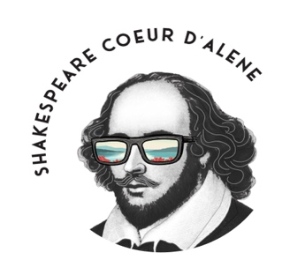

Playing Shakespeare
Summer Camp Registration Form
July 8-19, 2024
1:30pm-4:30pm
(please fill out one form per student)

Student Name: ________________________________________________________________

Student’s Date of Birth: ______________________________

School and Grade (2024-2025 school year): ________________________________________

Medical Conditions/Allergies:

______________________________________________________________________________

______________________________________________________________________________

Parent/Guardian Name: _______________________________________________________

Parent/Guardian Email: _______________________________________________________

Parent/Guardian Phone:_______________________________________________________

Tuition: $300 per student. Checks may be made payable to Shakespeare Coeur d’Alene and mailed to Shakespeare Coeur d’Alene PO Box 3662, Coeur d’Alene, ID 83816
Please note that the application will not be complete until payment has been received.

Questions? Please email our Artistic/Educational Director, Mary Bowers at mtbowers@shakespearecda.org

Application forms can be mailed with checks to the address above. You may also email the completed form to the above email address.

